**SQL ASSESSMENT**

CREATE DATABASE SCRIPT FOR EMPLOYEES DATABASE *****************************************************************************

DROP DATABASE IF EXISTS employees;

CREATE DATABASE IF NOT EXISTS employees; USE employees; SELECT 'CREATING DATABASE STRUCTURE' as 'INFO';

DROP TABLE IF EXISTS dept_emp, dept_manager, titles, salaries, employees, departments;

CREATE TABLE employees ( emp_no INT NOT NULL, birth_date DATE NOT NULL, first_name VARCHAR(14) NOT NULL, last_name VARCHAR(16) NOT NULL, gender ENUM ('M','F') NOT NULL, hire_date DATE NOT NULL, PRIMARY KEY (emp_no) );

CREATE TABLE departments ( dept_no CHAR(4) NOT NULL, dept_name VARCHAR(40) NOT NULL, PRIMARY KEY (dept_no), UNIQUE KEY (dept_name) );

CREATE TABLE dept_manager ( emp_no INT NOT NULL, dept_no CHAR(4) NOT NULL, from_date DATE NOT NULL, to_date DATE NOT NULL, FOREIGN KEY (emp_no) REFERENCES employees (emp_no) ON DELETE CASCADE, FOREIGN KEY (dept_no) REFERENCES departments (dept_no) ON DELETE CASCADE, PRIMARY KEY (emp_no,dept_no) );

CREATE TABLE dept_emp ( emp_no INT NOT NULL, dept_no CHAR(4) NOT NULL, from_date DATE NOT NULL, to_date DATE NOT NULL, FOREIGN KEY (emp_no) REFERENCES employees (emp_no) ON DELETE CASCADE, FOREIGN KEY (dept_no) REFERENCES departments (dept_no) ON DELETE CASCADE,PRIMARY KEY (emp_no,dept_no) );

CREATE TABLE titles ( emp_no INT NOT NULL, title VARCHAR(50) NOT NULL, from_date DATE NOT NULL, to_date DATE, FOREIGN KEY (emp_no) REFERENCES employees (emp_no) ON DELETE CASCADE, PRIMARY KEY (emp_no,title, from_date) ) ;

CREATE TABLE salaries ( emp_no INT NOT NULL, salary INT NOT NULL, from_date DATE NOT NULL, to_date DATE NOT NULL, FOREIGN KEY (emp_no) REFERENCES employees (emp_no) ON DELETE CASCADE, PRIMARY KEY (emp_no, from_date) ) ;

**Data**

INSERT INTO `departments` VALUES ('d001','Marketing'), ('d002','Finance'), ('d003','Human Resources'), ('d004','Production'),('d005','Development'), ('d006','Quality Management'),('d007','Sales'), ('d008','Research'),('d009','Customer Service'); INSERT INTO `employees` VALUES (10001,'1953-09-02','Georgi','Facello','M','1986-06-26'), (10002,'1964-06-02','Bezalel','Simmel','F','1985-11-21'), (10003,'1959-12-03','Parto','Bamford','M','1986-08-28'), (10004,'1954-05-01','Chirstian','Koblick','M','1986-12-01'), (10005,'1955-01-21','Kyoichi','Maliniak','M','1989-09-12'), (10006,'1953-04-20','Anneke','Preusig','F','1989-06-02'), (10007,'1957-05-23','Tzvetan','Zielinski','F','1989-02-10'), (10008,'1958-02-19','Saniya','Kalloufi','M','1994-09-15'), (10009,'1952-04-19','Sumant','Peac','F','1985-02-18'), (10010,'1963-06-01','Duangkaew','Piveteau','F','1989-08-24'),

(10011,'1953-11-07','Mary','Sluis','F','1990-01-22'), (10012,'1960-10-04','Patricio','Bridgland','M','1992-12-18'), (10013,'1963-06-07','Eberhardt','Terkki','M','1985-10-20'), (10014,'1956-02-12','Berni','Genin','M','1987-03-11'); INSERT INTO `dept_emp` VALUES (10001,'d005','1986-06-26','9999-01-01'), (10002,'d007','1996-08-03','9999-01-01'), (10003,'d004','1995-12-03','9999-01-01'), (10004,'d004','1986-12-01','9999-01-01'), (10005,'d003','1989-09-12','9999-01-01'),(10006,'d005','1990-08-05','9999-01-01'), (10014,'d005','1993-12-29','9999-01-01');INSERT INTO `dept_manager` VALUES (10013,'d001','1985-01-01','1991-10-01'), (10001,'d001','1991-10-01','9999-01-01'), (10002,'d002','1985-01-01','1989-12-17'), (10008,'d002','1989-12-17','9999-01-01'), (10012,'d003','1985-01-01','1992-03-21'), (10011,'d003','1992-03-21','9999-01-01'), (10014,'d004','1985-01-01','1988-09-09'), (10003,'d004','1988-09-09','1992-08-02'); INSERT INTO `salaries` VALUES (10001,60117,'1986-06-26','1987-06-26'), (10001,62102,'1987-06-26','1988-06-25'), (10002,66074,'1988-06-25','1989-06-25'), (10003,66596,'1989-06-25','1990-06-25'),(10004,66961,'1990-06-25','1991-06-25'), (10005,71046,'1991-06-25','1992-06-24'), (10006,74333,'1992-06-24','1993-06-24'), (10007,75286,'1993-06-24','1994-06-24'), (10008,75994,'1994-06-24','1995-06-24'); INSERT INTO `titles` VALUES (10001,'Senior Engineer','1986-06-26','9999-01-01'), (10002,'Staff','1996-08-03','9999-01-01'), (10003,'Senior Engineer','1995-12-03','9999-01-01'), (10004,'Engineer','1986-12-01','1995-12-01'), (10004,'Senior Engineer','1995-12-01','9999-01-01'), (10005,'Senior Staff','1996-09-12','9999-01-01'), (10005,'Staff','1989-09-12','1996-09-12'), (10006,'Senior Engineer','1990-08-05','9999-01-01'), (10007,'Senior Staff','1996-02-11','9999-01-01'), (10007,'Staff','1989-02-10','1996-02-11'), (10008,'Assistant Engineer','1998-03-11','2000-07-31');

**Do not copy this data from here.**

**Table Join Model**

**Tasks**

**1. Create a SQL statement to list all managers and their titles. (revisit)**

**First attempt**

SELECT dm.emp_no, e.first_name, e.last_name, t.title

FROM employees e

RIGHT JOIN titles t

ON e.emp_no = t.emp_no

RIGHT JOIN dept_manager dm

ON e.emp_no = dm. emp_no;

**Second attempt**

SELECT dm.emp_no, CONCAT(e.first_name, ‘ ‘, e.last_name) AS full_name, t.title

FROM dept_manager dm

LEFT JOIN employees e

ON dm.emp_no = e.emp_no

LEFT JOIN titles t

ON e.emp_no = t.emp_no

GROUP BY

dm.emp_no,

e.first_name,

e.last_name,

t.title;

**Output**

**2. Create a SQL statement to show the salary of all employees and their department name.**

SELECT s.emp_no, e.first_name, e.last_name, s.salary, d.dept_name

FROM salaries s

INNER JOIN employees e

ON s.emp_no = e.emp_no

INNER JOIN dept_emp de

ON e.emp_no = de.emp_no

INNER JOIN departments d

ON de.dept_no = d.dept_no;

**Second attempt**

Select dm.emp_no, CONCAT(e.first_name, ‘ ‘, e.last_name) AS full_name, s.salary, d.dept_name, COALESCE(de.dept_no, dm.dept_no) AS dept_no, s.from_date, s.to_date

From dept_manager dm

LEFT JOIN departments d

ON d.dept_no = dm.dept_no

LEFT JOIN employees e

ON dm.emp_no = e.emp_no

LEFT JOIN salaries s

ON e.emp_no = s.emp_no

LEFT JOIN dept_emp de

ON d.dept_no = de.dept_no

Union

SELECT s.emp_no, CONCAT(e.first_name, ‘ ‘, e.last_name) AS full_name, s.salary, d.dept_name, COALESCE(de.dept_no, dm.dept_no) AS dept_no, s.from_date, s.to_date

FROM employees e

LEFT JOIN salaries s

ON e.emp_no = s.emp_no

LEFT JOIN dept_emp de

ON e.emp_no = de.emp_no

LEFT JOIN departments d

ON de.dept_no = d.dept_no

LEFT JOIN dept_manager dm

ON dm.dept_no = d.dept_no;

**Outcome**

**3. Create a SQL statement to show the hire date and birth date who belongs to HR department**

SELECT e.emp_no, e.hire_date, e.birth_date, d.dept_name, de.to_date

FROM employees e

LEFT JOIN dept_emp de

ON e.emp_no = de.emp_no

LEFT JOIN departments d

ON de.dept_no = d.dept_no

WHERE d.dept_name = ‘Human Resources’;

**Outcome**

**Code including past employees**

**Second attempt**

SELECT e.emp_no, CONCAT(e.first_name, ‘ ‘, e.last_name) AS full_name, e.hire_date, e.birth_date, COALESCE(de.dept_no, dm.dept_no) AS dept_no, d.dept_name

FROM employees e

LEFT JOIN dept_emp de

ON e.emp_no = de.emp_no

LEFT JOIN dept_manager dm

ON e.emp_no = dm.emp_no

LEFT JOIN departments d

ON d.dept_no = COALESCE(de.dept_no, dm.dept_no)

WHERE d.dept_name = ‘Human Resources’

OR

COALESCE (de.dept_no, dm.dept_no) = ‘d003’;

**Output (Final answer)**

**4. Create a SQL statement to show all departments and their department’s managers.**

**First code**

SELECT COALESCE(de.dept_no, dm.dept_no) AS dept_no, d.dept_name, dm.emp_no, e.first_name, e.last_name

FROM departments d

LEFT JOIN dept_manager dm

ON d.dept_no = dm.dept_no

LEFT JOIN dept_emp de

ON d.dept_no = de.dept_no

LEFT JOIN employees e

ON de.emp_no = e.emp_no;

**second code**

SELECT COALESCE(de.dept_no, dm.dept_no) AS dept_no, d.dept_name, dm.emp_no, e.first_name, e.last_name

FROM dept_manager dm

INNER JOIN departments d

ON dm.dept_no = d.dept_no

INNER JOIN dept_emp de

ON d.dept_no = de.dept_no

INNER JOIN employees e

ON de.emp_no = e.emp_no;

**Third code**

SELECT d.dept_no, d.dept_name, dm.emp_no, CONCAT(e.first_name, ‘ ‘, e.last_name) AS full_name, dm. from_date, dm.to_date

FROM departments d

LEFT JOIN dept_manager dm

ON dm.dept_no = d.dept_no

LEFT JOIN employees e

ON dm.emp_no = e.emp_no

ORDER BY d.dept_no;

**Outcome**

**5. Create a SQL statement to show a list of HR’s employees who were hired after 1986**

SELECT e.emp_no, e.first_name, e.last_name, e.hire_date, COALESCE(de.dept_no, dm.dept_no) AS dept_no, d.dept_name

FROM employees e

LEFT JOIN dept_emp de

ON e.emp_no = de.emp_no

LEFT JOIN dept_manager dm

ON e.emp_no = dm.emp_no

LEFT JOIN departments d

ON d.dept_no = COALESCE(de.dept_no, dm.dept_no)

WHERE d.dept_name = ‘Human Resources’

OR

COALESCE (de.dept_no, dm.dept_no) = ‘d003’

AND e.hire_date > ‘1986-01-01’;

**Outcome**

**6. Create a SQL statement to increase any employee’s salary up to 2%. Assume the employee has just phoned in with his/her last name.**

UPDATE salaries

SET salary = salary * 1.02

WHERE emp_no IN (

SELECT e.emp_no

FROM employees e

WHERE e.last_name = 'last_name'

);

**Here you would swap the last name for the person you are increasing the salary for. This query will then update the salary by 2%**

**Original Data**

**Outcome (lets use Bezalel Simmel)**

UPDATE salaries

SET salary = salary * 1.02

WHERE emp_no IN (

SELECT e.emp_no

FROM employees e

WHERE e.last_name = 'Simmel'

);

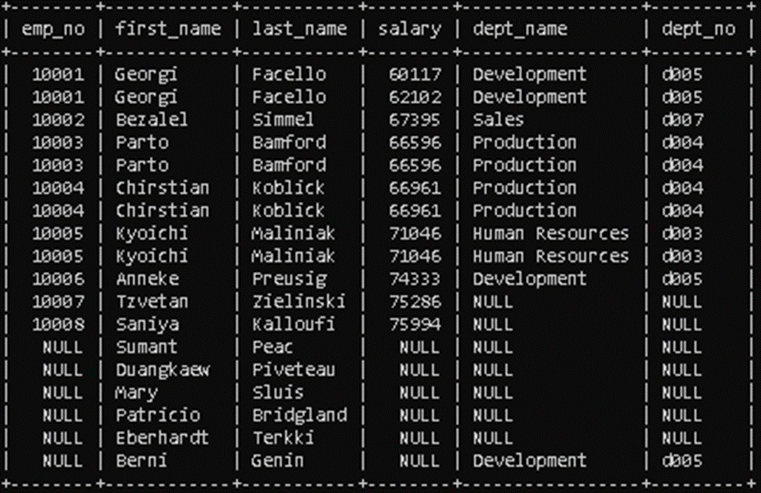

**This query was tested on a duplicate database, called ‘employee_test’ to ensure the original data is not altered.**

**7. Create a SQL statement to delete employee’s record who belongs to marketing department and name start with A**

DELETE FROM employees

WHERE emp_no IN (SELECT e.emp_no

FROM employees e

JOIN dept_emp de ON e.emp_no = de.emp_no

JOIN departments d ON de.dept_no = d.dept_no

LEFT JOIN dept_manager dm ON d.dept_no = dm.dept_no

WHERE (d.dept_no = 'd001' OR d.dept_name = 'Marketing')

AND e.first_name LIKE ‘A%’);

**To check if delete has worked. You would use this query**

SELECT e.emp_no, e.first_name, e.last_name, COALESCE(de.dept_no, dm.dept_no) AS dept_no, d.dept_name, COALESCE(de.from_date, dm.from_date) AS dept_from_date, COALESCE(de.to_date, dm.to_date) AS dept_to_date, s.salary, s.from_date AS salary_from_date, s.to_date AS salary_to_date

FROM employees e

LEFT JOIN dept_emp de ON e.emp_no = de.emp_no

LEFT JOIN dept_manager dm ON e.emp_no = dm.emp_no

LEFT JOIN departments d ON d.dept_no = COALESCE(de.dept_no, dm.dept_no)

LEFT JOIN salaries s ON e.emp_no = s.emp_no

ORDER BY e.emp_no, COALESCE(de.from_date, dm.from_date, s.from_date), COALESCE(de.to_date, dm.to_date, s.to_date);

**Outcome of this query**

**8. Create a database view to list the full names of all departments’ managers, and their salaries.**

CREATE VIEW department_managers_with_salaries AS

SELECT e.emp_no AS EmployeeNumber, CONCAT(e.first_name, ' ', e.last_name) AS FullName, d.dept_name AS DepartmentName, s.salary AS CurrentSalary

FROM dept_manager dm

INNER JOIN employees e ON e.emp_no = dm.emp_no

LEFT JOIN departments d ON dm.dept_no = d.dept_no

LEFT JOIN salaries s ON e.emp_no = s.emp_no;

**Outcome of managers who have salaries**

**9. Create a database view to list all departments and their department’s managers, who were hired between 1980 and 1990**

CREATE VIEW department_managers_hired AS

Select d.dept_no, d.dept_name, dm.emp_no, dm.from_date, dm.to_date, CONCAT(e.first_name, ' ', e.last_name) AS FullName, e. hire_date

FROM departments d

LEFT JOIN dept_manager dm ON d.dept_no = dm.dept_no

LEFT JOIN employees e ON dm.emp_no = e.emp_no

WHERE e.hire_date BETWEEN ‘1980-01-01’ AND ‘1990-01-01’;

**10. Create a SQL statement to increase salaries of all department’s managers up to 10% who are working since 1990.**

**Step 1**

**CREATE TEMPORARY TABLE manager_inc AS**

SELECT d.dept_no, d.dept_name, dm.emp_no, e.first_name, e.last_name, e.hire_date, dm. from_date, dm.to_date, s.salary

FROM dept_manager dm

LEFT JOIN departments d

ON dm.dept_no = d.dept_no

LEFT JOIN employees e

ON dm.emp_no = e.emp_no

LEFT JOIN salaries s

ON e.emp_no = s.emp_no

WHERE YEAR(e.hire_date) <= ‘1990’

AND YEAR(dm.to_date) = ‘9999’;

**Outcome**

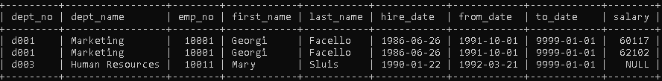

**Query to increase salary**

UPDATE manager_inc

SET salary = salary * 1.10

WHERE emp_no IN (SELECT e.emp_no

FROM employees e

WHERE YEAR(e.hire_date) <= '1990’

AND YEAR(dm.to_date) = ‘9999’

**Original data**

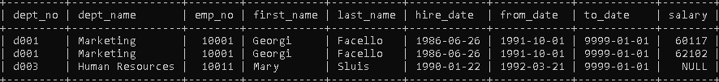

**Updated**

**Table of employee details, salary, department name, department number**

SELECT s.emp_no, e.first_name, e.last_name, s.salary, d.dept_name, COALESCE(de.dept_no, dm.dept_no) AS dept_no

FROM employees e

LEFT JOIN salaries s

ON e.emp_no = s.emp_no

LEFT JOIN dept_emp de

ON e.emp_no = de.emp_no

LEFT JOIN departments d

ON de.dept_no = d.dept_no

LEFT JOIN dept_manager dm

ON dm.dept_no = d.dept_no;

**Duplicate database to test queries**

CREATE DATABASE IF NOT EXISTS employees test

USE employees test; SELECT 'CREATING DATABASE STRUCTURE' as 'INFO'; DROP TABLE IF EXISTS dept_emp, dept_manager, titles,

salaries, employees, departments; CREATE TABLE employees ( emp_no INT NOT NULL, birth_date DATE NOT NULL, first_name VARCHAR(14) NOT NULL, last_name VARCHAR(16) NOT NULL, gender ENUM ('M','F') NOT NULL, hire_date DATE NOT NULL, PRIMARY KEY (emp_no) ); CREATE TABLE departments ( dept_no CHAR(4) NOT NULL, dept_name VARCHAR(40) NOT NULL, PRIMARY KEY (dept_no), UNIQUE KEY (dept_name) ); CREATE TABLE dept_manager ( emp_no INT NOT NULL, dept_no CHAR(4) NOT NULL, from_date DATE NOT NULL,

to_date DATE NOT NULL, FOREIGN KEY (emp_no) REFERENCES employees (emp_no) ON DELETE CASCADE, FOREIGN KEY (dept_no) REFERENCES departments (dept_no) ON DELETE CASCADE, PRIMARY KEY (emp_no,dept_no) ); CREATE TABLEdept_emp ( emp_no INT NOT NULL, dept_no CHAR(4) NOT NULL, from_date DATE NOT NULL, to_date DATE NOT NULL, FOREIGN KEY (emp_no) REFERENCES employees (emp_no) ON DELETE CASCADE, FOREIGN KEY (dept_no) REFERENCES departments (dept_no) ON DELETE CASCADE,PRIMARY KEY (emp_no,dept_no) ); CREATE TABLE titles ( emp_no INT NOT NULL, title VARCHAR(50) NOT NULL, from_date DATE NOT NULL, to_date DATE, FOREIGN KEY (emp_no) REFERENCES employees (emp_no) ON DELETE CASCADE, PRIMARY KEY (emp_no,title, from_date) ) ; CREATE TABLE salaries ( emp_no INT NOT NULL, salary INT NOT NULL, from_date DATE NOT NULL, to_date DATE NOT NULL, FOREIGN KEY (emp_no) REFERENCES employees (emp_no) ON DELETE CASCADE, PRIMARY KEY (emp_no, from_date) ) ;

CREATE DATABASE IF NOT EXISTS employees test

USE employees test; SELECT 'CREATING DATABASE STRUCTURE' as 'INFO'; DROP TABLE IF EXISTS dept_emp, dept_manager, titles, salaries, employees, departments; CREATE TABLE employees ( emp_no INT NOT NULL, birth_date DATE NOT NULL, first_name VARCHAR(14) NOT NULL, last_name VARCHAR(16) NOT NULL, gender ENUM ('M','F') NOT NULL, hire_date DATE NOT NULL, PRIMARY KEY (emp_no) ); CREATE TABLE departments ( dept_no CHAR(4) NOT NULL, dept_name VARCHAR(40) NOT NULL, PRIMARY KEY (dept_no), UNIQUE KEY (dept_name) ); CREATE TABLE dept_manager ( emp_no INT NOT NULL, dept_no CHAR(4) NOT NULL, from_date DATE NOT NULL, USto_date DATE NOT NULL, FOREIGN KEY (emp_no) REFERENCES employees (emp_no) ON DELETE CASCADE, FOREIGN KEY (dept_no) REFERENCES departments (dept_no) ON DELETE CASCADE, PRIMARY KEY (emp_no,dept_no) ); CREATE TABLEdept_emp ( emp_no INT NOT NULL, dept_no CHAR(4) NOT NULL, from_date DATE NOT NULL, to_date DATE NOT NULL, FOREIGN KEY (emp_no) REFERENCES employees (emp_no) ON DELETE CASCADE, FOREIGN KEY (dept_no) REFERENCES departments (dept_no) ON DELETE CASCADE,PRIMARY KEY (emp_no,dept_no) ); CREATE TABLE titles ( emp_no INT NOT NULL, title VARCHAR(50) NOT NULL, from_date DATE NOT NULL, to_date DATE, FOREIGN KEY (emp_no) REFERENCES employees (emp_no) ON DELETE CASCADE, PRIMARY KEY (emp_no,title, from_date) ) ; CREATE TABLE salaries ( emp_no INT NOT NULL, salary INT NOT NULL, from_date DATE NOT NULL, to_date DATE NOT NULL, FOREIGN KEY (emp_no) REFERENCES employees (emp_no) ON DELETE CASCADE, PRIMARY KEY (emp_no, from_date) ) ;

fix

Question 2

6 – temporay table, stored procedure

7 – temporary table

8 – georgy had no salary in marketing

10 – redo.